CHAPTER FIVE

DETAILED DESIGN OF THE PROPOSED SYSTEM

5.0 Functional Processes of the Proposed System
The financial mobile platform mobile Application for Koforidua Technical University is designed to provide a secure, efficient, and user-friendly platform for managing student fee payments. The system operates through a series of interconnected functional processes that facilitate smooth interaction between students, the application, the database, and external payment services.
The process begins with user registration and authentication, where students create accounts using their personal details, including their name, index number, email address, and phone number. The system validates the information provided to ensure accuracy and uniqueness before creating and activating the student account. This process guarantees that only authorized students can access the application and its services.
After successful registration, students can access the system through the login and session management process. During login, students enter their registered email address or phone number together with their password. The system verifies these credentials against stored records in the database and, upon successful authentication, initiates a secure user session. This session remains active until the user logs out or the session expires, ensuring the security of user data and transactions.
Once authenticated, the student is directed to the dashboard, where the fee retrieval process is executed. The system communicates with the database to retrieve the student’s fee information, including outstanding balances and payment history. This information is then displayed on the dashboard, enabling students to view their current financial obligations and make informed payment decisions.
The payment processing process allows students to settle their fees electronically through integrated digital payment platforms. Students select the fee category they wish to pay and choose their preferred payment method, such as mobile money or other supported digital payment services. The application sends the payment request to a secure payment gateway, which processes the transaction and returns a confirmation response to the system.
Following a successful transaction, the system performs the transaction recording process. Payment details, including transaction reference numbers, payment amounts, payment dates, and payment methods, are stored securely in the database. At the same time, the student’s account balance is automatically updated to reflect the completed payment. This process ensures accurate financial record keeping and supports future transaction tracking and auditing.
After recording the transaction, the system initiates the receipt generation process. A digital receipt is automatically generated in PDF format containing essential transaction details such as the student’s information, payment amount, transaction reference, date, and confirmation status. The generated receipt is stored within the system and made available for download whenever required by the student.
Finally, the application executes the notification process to keep users informed about transaction activities. Upon successful payment, the system sends real-time notifications through SMS, email, or push notifications to confirm the transaction. These notifications provide immediate feedback to students and serve as an additional layer of assurance that payments have been successfully completed and recorded.
Together, these functional processes form an integrated workflow that automates fee payment management, improves transaction transparency, enhances user convenience, and reduces the administrative burden associated with traditional payment methods at Koforidua Technical University.

5.1 Algorithms and Flowchart of the System

5.1.1. Algorithm For financial mobile platform
Step 1:
- Start the system.
Step 2: Registration
- Student are registered in administration time.
Step 3: Login
- Student enters email and password.
- System verifies credentials.
- If credentials are incorrect, display login error.
- If credentials are correct, create user session and open dashboard.
Step 4: Retrieve Fees
- System fetches student fee records from the database.
- Display outstanding fees and payment history.
Step 5: Process Payment
- Student selects fee type.
- Student selects payment method (Mobile Money/Card).
- System sends payment request to payment gateway.
- Payment gateway processes transaction.
Step 6: Check Payment Status
- If payment fails, display failure message and allow retry.
- If payment succeeds, continue to next step.
Step 7: Record Transaction
- Store transaction details in the database.
- Update student account balance.
Step 8: Generate Receipt
- Create PDF receipt.
- Store receipt in the system.
- Make receipt available for download.
Step 9: Send Notification
- Send SMS/email/push notification confirming payment.
Step 10:
- End process.

5.1.2. Flowchart For financial mobile platform
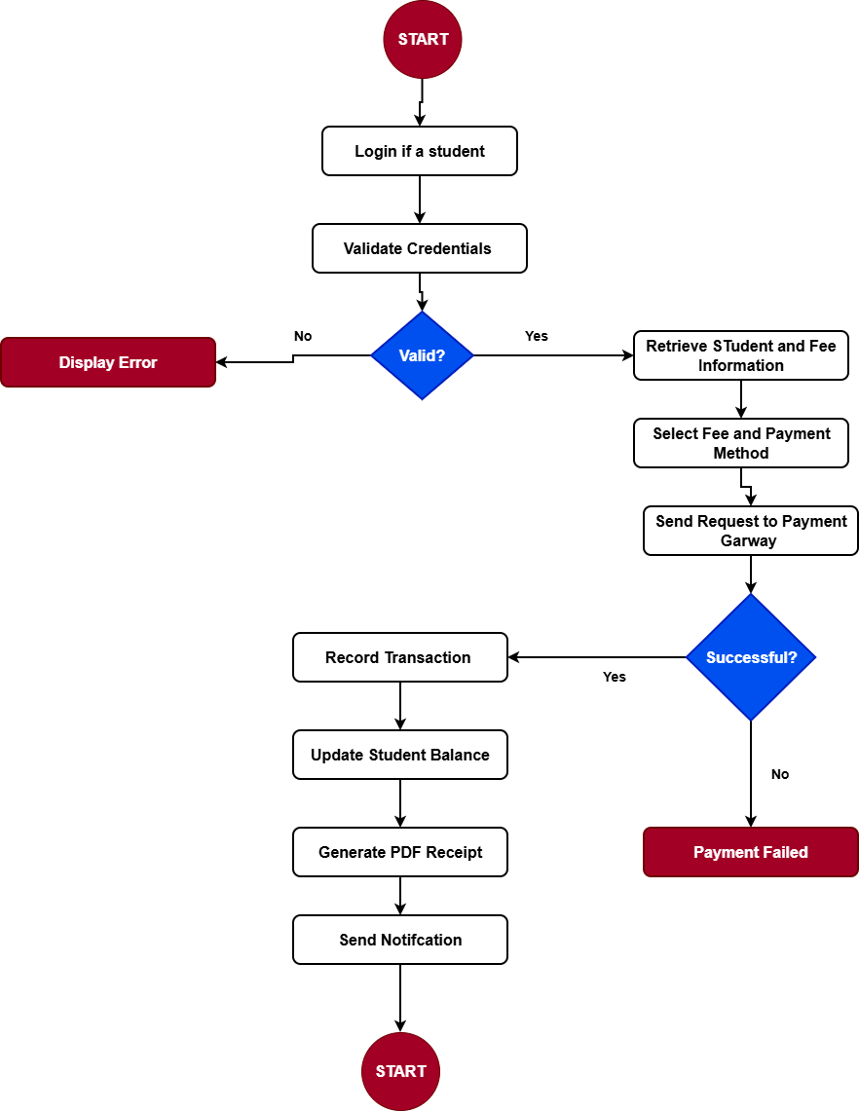

5.2 Process Models

5.2.1 Data Flow Diagram (DFD) – Level 0 (Context Level)
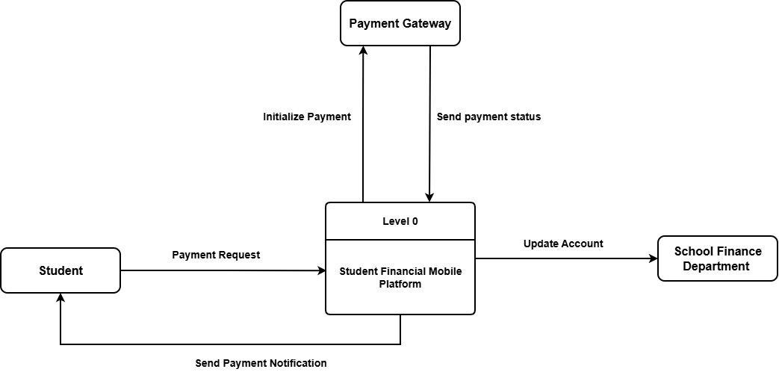

5.2.2 DFD Level 1
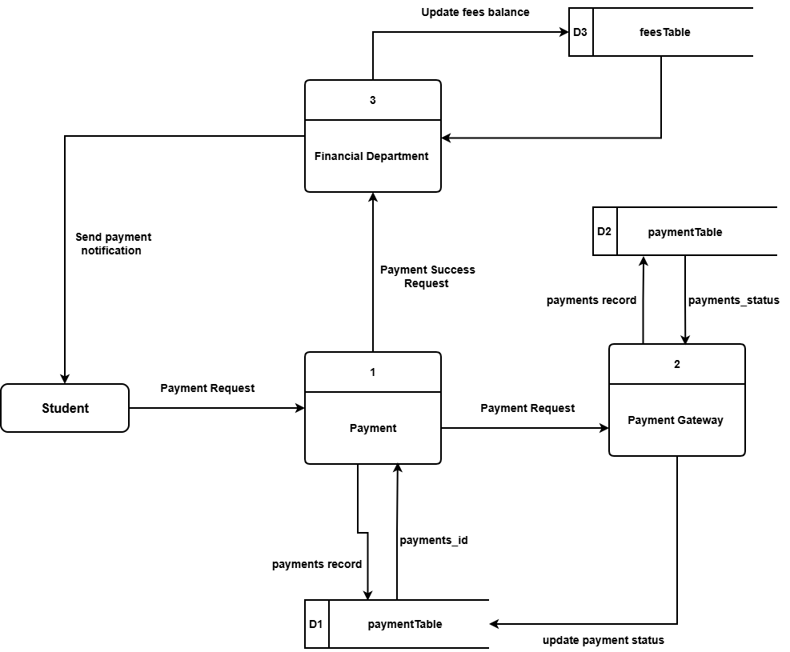

5.2.3 Use Case Diagram (Student)
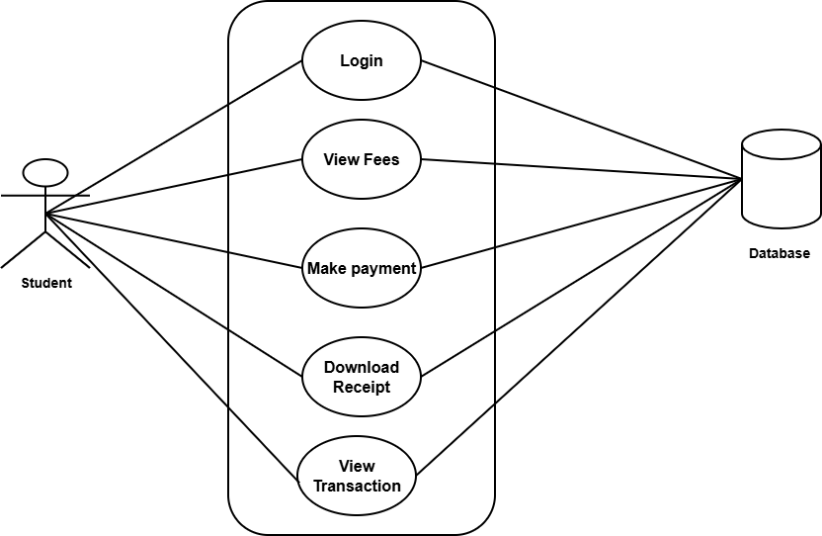

Student Use Case Description
The student is the primary actor of the student financial Mobile Application and interacts with the system to manage fee payments and related financial activities. The student begins by logging into the application using their registered credentials, which are authenticated by the system to grant secure access. After successful login, the student can view their current fee information, including outstanding balances and payment details. The student may then initiate a payment by selecting the desired fee category and preferred payment method. Once the payment is successfully processed, the system records the transaction and generates a digital receipt that the student can download for future reference. Additionally, the student can access and view their transaction history, allowing them to track all previous payments and monitor their financial records within the university system. This use case ensures a convenient, secure, and efficient fee payment experience for students.

5.2.4 Sequence Diagram (Student)
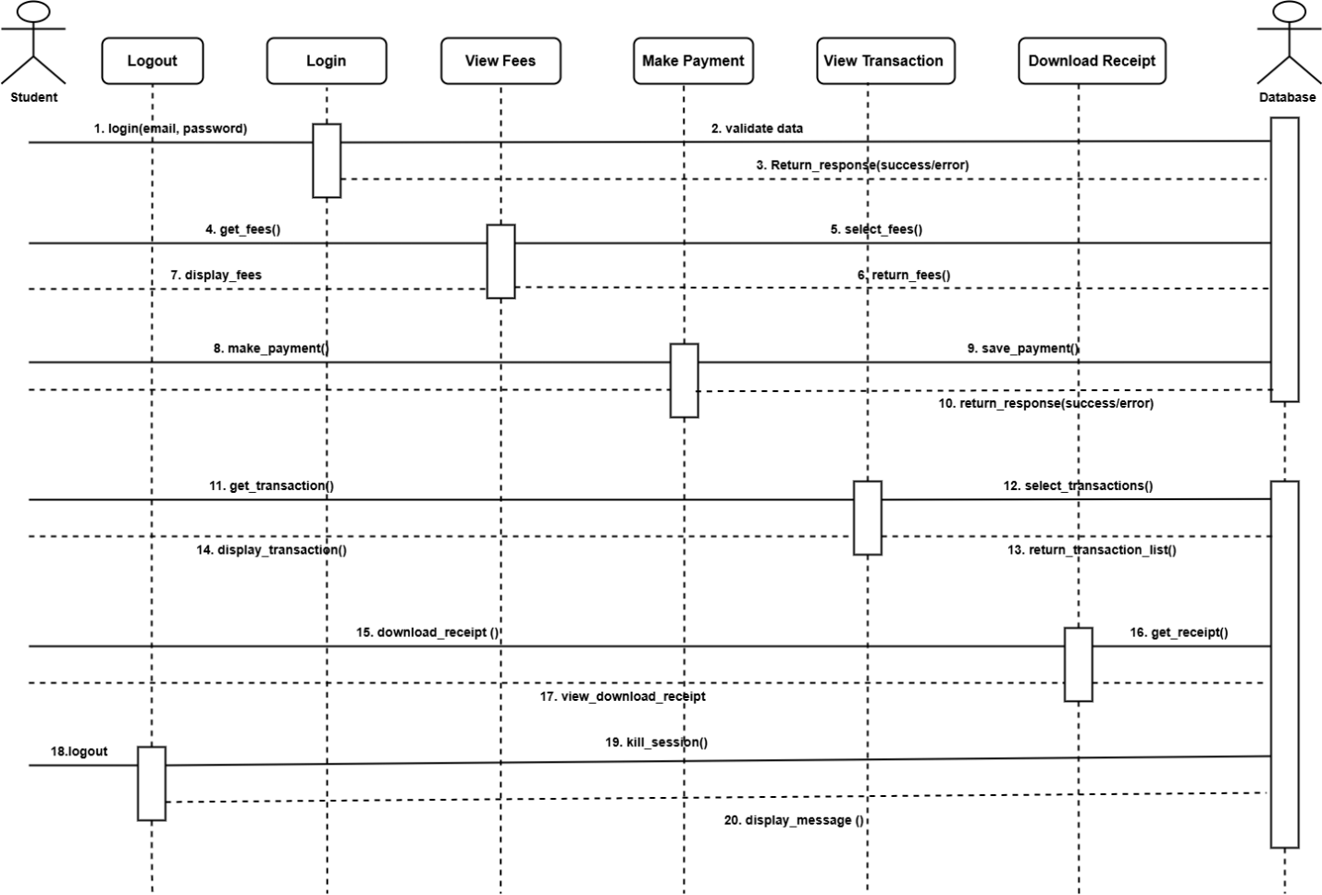
Sequence Diagram Description
The sequence diagram for the student financial Mobile Application illustrates the interaction between the Student, Mobile Application, Database, Payment Gateway, and Notification Service during the fee payment process. The process begins when the student logs into the mobile application by providing valid credentials. The application forwards the login request to the database for verification, and upon successful authentication, access is granted to the student. The student then requests to view fee information, prompting the application to retrieve the student's outstanding fees from the database and display them on the dashboard. When the student decides to make a payment, the payment details are submitted through the application and forwarded to the payment gateway for processing. The payment gateway validates and processes the transaction before returning the payment status to the application. If the transaction is successful, the application records the payment details in the database and updates the student's account balance. The system then generates a digital receipt and stores it for future access. Subsequently, a notification service sends a confirmation message via SMS, email, or push notification to the student. Finally, the student can download the generated receipt and view the updated transaction history, completing the sequence of interactions within the system.

5.3 Data Models

5.3.1 Data Dictionary (Class diagram)
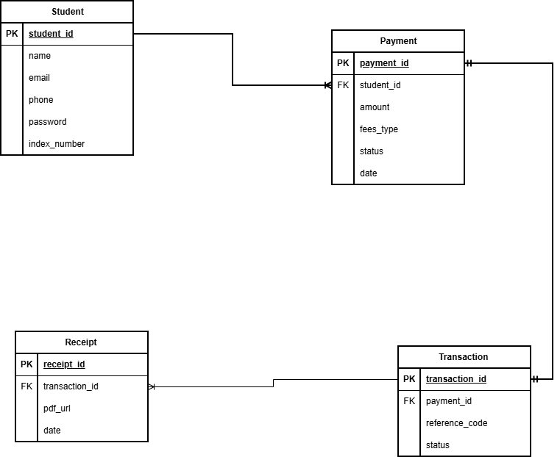

Database Table Description
The Student Financial Mobile Platform Application utilizes a relational database structure consisting of four primary tables: Student, Payment, Transaction, and Receipt. These tables are designed to store and manage student information, payment records, transaction details, and generated receipts while maintaining data integrity through the use of primary and foreign key relationships.
The student table stores information about registered users of the application. It contains the unique student identifier (student_id) as the primary key, along with the student's name, email address, phone number, password, and index number. This table serves as the central repository for student account information and is used during registration, authentication, and fee payment activities.
The Payment table records all fee payment requests initiated by students. Each payment record is uniquely identified by payment_id, which serves as the primary key. The table also contains student_id as a foreign key that links each payment to a specific student in the student table. Additional attributes include the payment amount, fee type, payment status, and the date on which the payment was made. This table enables the system to track fee payments and monitor payment progress.
The Transaction table stores detailed information about completed payment transactions. The table uses transaction_id as its primary key and references the Payment table through payment_id, which acts as a foreign key. It also stores the transaction reference code generated by the payment gateway, the payment method used, and the transaction status. This table provides a detailed audit trail for all financial transactions processed by the system.
The Receipt table manages digital receipts generated after successful transactions. Each receipt is uniquely identified by receipt_id, which serves as the primary key. The table contains transaction_id as a foreign key linking the receipt to a specific transaction. Additional fields include the PDF file location (pdf_url) and the date and time the receipt was generated (generated_at). This table ensures that students can access and download proof of payment whenever required.
The relationships between these tables are established through foreign keys. A single student can make multiple payments, creating a one-to-many relationship between the Student and Payment tables. Similarly, each payment is associated with a transaction, and each transaction can generate a receipt. These relationships ensure efficient data management, reduce redundancy, and support the overall functionality of the Student Pay Mobile Application.

5.3.2 Database Schema (Overview)
- Students Table
- Payments Table
- Transactions Table
- Receipts Table

5.3.3 Entity Relationship Diagram (ERD Description)
- A Student can make many Payments
- Each Payment generates one Transaction
- Each Transaction generates one Receipt
- Payments are linked to Student via student_id

5.4 User Interface Design (Views)
The system will include the following UI screens:
1. Login Screen
2. Dashboard
3. Payment Screen
4. Receipt Screen
5. Admin Panel

5.5 Interactivity and System Modeling

5.5.1 Collaboration Diagram Description
The collaboration diagram illustrates how the various components of the Student Pay Mobile Application interact to facilitate fee payment transactions. The process begins when the student interacts with the user interface (UI) module by entering login credentials, viewing fee information, or initiating a payment. The UI module forwards the user's requests to the Application Programming Interface (API) layer, which serves as the intermediary between the mobile application and the backend services. The API layer communicates with the database to retrieve student records, fee information, transaction histories, and receipt details. During payment processing, the API sends payment requests to the payment gateway, which validates and processes the transaction. Once the transaction is completed, the payment gateway returns a response indicating whether the payment was successful or unsuccessful. The API then updates the database accordingly and sends the appropriate feedback to the user interface for display to the student. This collaborative interaction ensures seamless communication among all system components and supports efficient processing of student fee payments.

5.5.2 State Diagram Description
The state diagram represents the various states through which a payment transaction progresses within the Student Pay Mobile Application. The payment process begins in the Initiated state when a student submits payment details. The payment then moves to the Pending state while awaiting validation and processing by the payment gateway. Once validation is completed, the payment enters the Processing state, during which the payment gateway attempts to complete the transaction. If the transaction is approved and completed successfully, the payment transitions to the Successful state, triggering transaction recording, receipt generation, and notification delivery. However, if any error occurs during processing, such as insufficient funds, network issues, or gateway rejection, the payment transitions to the Failed state. These states enable the system to monitor payment progress and provide accurate feedback to students throughout the transaction lifecycle.

5.5.3 IPO Model (Input–Process–Output) Description
The Input–Process–Output (IPO) model describes how data is transformed within the Student Pay Mobile Application. The input stage consists of student credentials, payment details, and selected fee types provided by the student through the mobile application. During the processing stage, the system authenticates the student, validates payment information, processes the transaction through the payment gateway, verifies transaction results, and generates a digital receipt. The output stage produces payment confirmations, downloadable PDF receipts, and updated transaction histories that are displayed to the student. This model demonstrates how raw user data is processed into meaningful information and services that support efficient fee payment management.

5.5.4 HIPO Chart Description
The Hierarchy plus Input–Process–Output (HIPO) chart provides a hierarchical representation of the Student Pay Mobile Application and its major functional modules. At the highest level (Level 0), the entire system is represented as the Student Pay System. At Level 1, the system is divided into four major modules: Authentication Module, Payment Module, Transaction Module, and Notification Module. The Authentication Module manages user registration and login activities, while the Payment Module handles fee payments and interactions with the payment gateway. The Transaction Module records payment information and maintains transaction histories, whereas the Notification Module manages SMS, email, and push notifications. At Level 2, the Payment Module is further decomposed into smaller functions including payment validation, payment gateway processing, and receipt generation. This hierarchical structure provides a clear view of the system's organization and illustrates how individual functions contribute to the overall operation of the Student Pay Mobile Application.

5.6 Chapter Summary
This chapter presented a detailed design of the Student Pay Mobile Application for Koforidua Technical University. It covered functional processes, system algorithms, flowcharts, data flow diagrams, UML models, database design, and user interface design.
The design demonstrates a complete blueprint of how the system will operate, how data will flow between components, and how users will interact with the system. This provides a strong foundation for system implementation in Chapter Six.

